**Operating systems 2 Lab test 2**

Using Putty to connect to Linux server (147.252.234.34) complete the following lab test.

Set up the Putty console so that the *Default background colour is white*; the *default foreground colour is black* -. This makes the screen shots clearer in a work document.

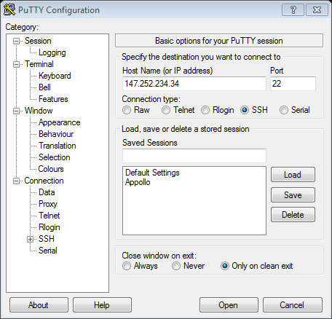

Colour change option

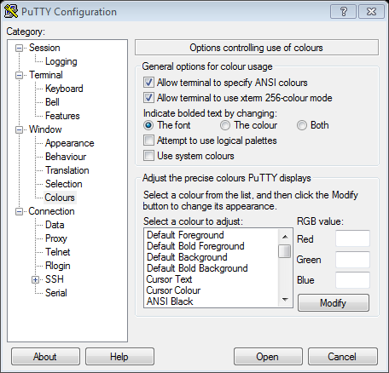

You are given the skeleton code for an implementation of the *producer/ consumer* problem using semaphores. Labtest2.c

1 You must insert code at the places indicated in the skeleton code in order to get the program to implement the producer/consumer problem.

**NB compile using gcc –o labest 2 labtest2.c –lpthread -lrt**

1. The student must insert *screen shots of the code* in a document called **LabTest 2**

**(60 marks)**

1. The threaded program must be *run three times* and screen shots of the output also put in the **LabTest 2** document. **(10 marks)**

1. The student must give *an explanation* of the output or expected output (if not completed) in the **LabTest 2** document. This must clearly describe how semaphores ensures that the bounded buffer will not allow the producer to add items to a buffer that is full and will not allow the consumer to remove elements from an empty buffer. **(30 marks)**

The lab test 3 document must be submitted via webcourses at the end of the lab test (**Monday the 12 of December 2016 at 18:35**).

A sample output:

